California's 1st Operational Dairy Digester Pipeline Cluster

Recently, Calgren Renewable Fuels hosted over 200 people in Tulare County, California to celebrate the state’s first operational dairy digester pipeline cluster. While one other dairy biogas pipeline project exists in Fair Oaks Indiana, the Calgren Dairy Fuels (CDF) facility is the first of its kind in California. Having received grants to build another 12 covered lagoon digesters that will supply biogas to this central hub located at the Calgren ethanol refinery, it is the largest project in the nation to inject biomethane into a utility pipeline. That said, the pipeline has been built for significant expansion.

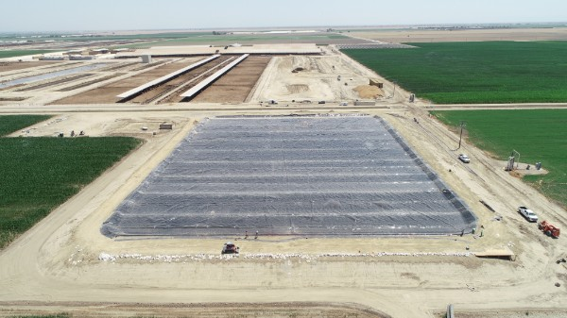
Covered Lagoon digester at Legacy Ranch, will be 3rd complete digester in the CDF Pipeline Cluster.

Each dairy in the cluster will supply their manure to an on-site digester operated by CDF. The biogas from these digesters will be transported to the CDF plant through a low pressure, private pipeline. So far, the project has laid over ten miles of mainline pipe. The project will provide dairy biogas for the ethanol refinery power plant and inject biomethane into the SoCalGas utility pipeline for use as CNG vehicle fuel. Biogas is already being delivered from 4J Farms (Junio family) and Circle A Dairy (Airoso family) while several more dairies are expected to go online in the coming months.
As far as is publicly known, no digester pipeline clusters have yet started construction other than Calgren Dairy Fuels. However, Maas Energy Works, developer for Calgren Dairy Fuels, is working on five additional clusters and has received various grants to build them. California Bioenergy, an early, strong proponent of digester clusters has also received grants for approximately six more clusters in development.

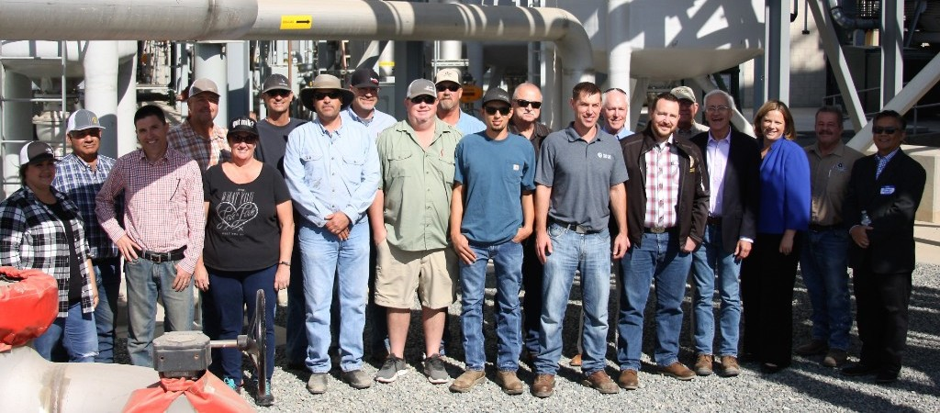

Photo from the Ribbon Cutting of some of the stakeholders who have made this project possible.

